An Integrated Analysis of Global Electricity Consumption, Renewable Energy, and Transmission Losses
Tauqeer ul Hassan
x24275174@student.ncirl.ie
Eisa Bin Ahsan
x24258687@student.ncirl.ie
Zain Bin Yaseen
x24274861@student.ncirl.ie
Abstract
Electricity is a key variable in economic growth, sustainability and life quality. The project examines the trend of electricity globally based on the publicly accessible World Bank data on the consumption of electricity, renewable electricity generation, and transmission and distribution losses. Three indicators were chosen to reflect various aspects of national electricity systems and include electricity consumption per capita, the share of renewable electricity in the total electricity production and the electricity losses in the transmission and distribution.
The data were acquired in diverse formats (JSON, XML and CSV) and handled by an all-automated data pipeline created in Python. The transformations and data cleaning and integration were performed in a programmatic way, and standardised country codes were applied to make sure that every dataset was consistent. The processed data were stored in CSV format and a NoSQL Mongo DB database to ensure reproducibility and scalability. A streamlit interactive dashboard was created to visualise trends, comparisons, and relationships between the indicators between countries and through the course of time.
These findings demonstrate that there are evident disparities in electricity use, renewable uptake, and efficiency of the infrastructure between nations and regions. Demand, sustainability, and efficiency indicators combined in the project allow getting the entire picture of the global electricity systems and prove the importance of organised data processing and visualisation in analysing the energy.
Keywords
Global electricity analysis, Renewable energy share, Electricity consumption per capita, Energy efficiency, Data integration, Interactive data visualization
Introduction
Electricity is one of the key elements of civilized communities, as it contributes to the rise of the economy and industries and the quality of life in general. With the ever-growing demand to consume electricity all over the world, there is a growing concern not only on the amounts of electricity that is consumed, but also the mode of its productions and efficiency of its delivery to the final consumers. The issues are specifically applicable to climate change, sustainable development, and ageing energy infrastructure.
Over the past few years, renewable sources such as solar, wind and hydropower have been invested in by many countries so as to curb dependence on fossil fuels and minimize on the environmental impact. Meanwhile, the problem of electricity transmission and distribution losses is also rather serious, particularly in underdeveloped areas, inefficient infrastructure may cause a considerable amount of energy waste. The combination of knowledge of electricity use, renewable energy use, and efficiency of the system gives a more holistic view of the national electricity systems as compared to studying one factor alone.
The project is a combined study of energy data in the world based on the freely available information of the World Bank. Three indicators are looked at and they include: electricity consumption per capita, renewable electricity production as a percentage of overall electricity generation and electricity transmission and distribution losses. These measures were chosen to indicate the level of electricity demand, sustainability in the supply and efficiency in the delivery, respectively.

The core purpose of this project is to understand the global trends and tendencies in electricity systems by combining heterogeneous data and showing the findings in the form of interactive visualisation. To be more precise, the following research questions will be considered within the scope of the project:
What are the differences in consumption of electricity in countries and over time?
What are the trends in the global and national use of renewable electricity?
What is the relationship between electricity transmission and distribution loss and consumption as well as the use of renewable energy?
To do this, a fully automated data processing pipeline using Python was created. The pipeline fetches the data in various formats, cleans and transforms, consolidates the data sets by using standardised country and temporal identifiers and stores the processed data to be analysed and visually represented. The interactive dashboard was then developed to facilitate the exploration analysis and use comparisons between countries and periods.
Related Work
Electricity systems have been extensively researched through various angles which include electricity consumption, renewable energy integration and inefficiency of infrastructure. It has been demonstrated in the past that electricity use per capita is closely related with economic development and livelihood and therefore it is widely utilized as an indicator in the energy and development literature [2], [5]. Nevertheless, consumption studies usually do not pay attention to the method of electricity production or its effective delivery to consumers.
A considerable amount of literature has focused on the issue of renewable energy in the attainment of the sustainable development objectives. The article by Strielkowski et al. [1] offers a thorough overview of the renewable electricity production and how it has contributed to the sustainable power systems, stating the economic and technical issues related to the integration of renewable energy. On the same note, Kocak [2] examines the effects of electricity produced in renewable and non-renewable sources in an empirical manner, which shows that, in favorable policy circumstances, renewable electricity will lead to better energy results. Although these articles are good sources of information on the adoption of renewables, they are mostly based on the generation mix but do not specifically mention how efficient transmission and distribution are.
The losses in electricity transmission and distribution have been given a relatively less attention although they have significance in the analysis of infrastructure performance. Research works like Kwakwa [6] and the empirical model presented in [7] indicate that grid quality, investment levels and governance structures contribute to the losses of electricity. Not only do high losses decrease the efficiency of the system, but also raise the effective cost of electricity supply. Experience has also associated the losses of electricity with more extensive environmental and economic consequences with ineffective grids potentially nullifying the utility of renewable energy growth [3], [4].
Multivariate methods have been embraced in more recent studies to examine interdependencies of the electricity demand, renewable generation and system performance. Durante et al. [8] emphasize a unity of analysis of various variables of electricity-related variables and demonstrate that electricity demand and supply of renewable are not independent of each other but are interrelated. Also, studies of high renewable penetration point out that high renewable shares may impose extra burdens on the available grid infrastructure unless supplemented with proper system improvements [9], [10].
Although considerable literature has been done on the individual components of electricity system, there are limited sources that incorporate electricity consumption, renewable electricity generation and transmission losses in a single framework of analysis on a global level. Several current studies use one indicator or region-specific analysis, which inhibits the chances of identifying interactions on the system level. The project is based on the previous studies but it incorporates these three indicators which are complementary to each other with the help of heterogeneous World Bank data and integrates automated data processing with interactive visualisation. Through this it fills a gap in the literature and gives a more holistic outlook of the global electricity systems.
Data Processing Methodology
This section describes the datasets used in the project, the data processing activities performed, the algorithms implemented, and the technologies selected. The overall goal of the methodology was to build a reproducible, automated, and scalable pipeline capable of integrating heterogeneous global electricity datasets for analysis and visualisation.
Datasets Description and Justification
The project uses three publicly available datasets from the World Bank World Development Indicators (WDI) database. These datasets were selected due to their global coverage, reliability, and relevance to analysing different dimensions of electricity systems.
- Electricity Consumption per Capita (EG.USE.ELEC.KH.PC)
This dataset measures average electricity consumption per person in kilowatt-hours. It was chosen to represent electricity demand and to allow meaningful comparisons across countries with different population sizes.
- Renewable Electricity Output (% of Total) (EG.ELC.RNEW.ZS)
This dataset represents the share of electricity generated from renewable sources such as solar, wind, and hydropower. It was selected to capture the sustainability and energy transition aspect of national electricity systems.
- Electricity Transmission and Distribution Losses (% of Output) (EG.ELC.LOSS.ZS)
This dataset measures the percentage of electricity lost during transmission and distribution. It was included to assess infrastructure efficiency and system performance.
Together, these datasets provide a complementary view of electricity demand, supply composition, and delivery efficiency, enabling a holistic analysis of global electricity systems.
Data Acquisition and Processing Activities
The datasets were obtained using different data formats, reflecting real-world data heterogeneity:
- JSON API was used to retrieve electricity consumption data.
- CSV files were used for renewable electricity output data.
- XML API was used to retrieve electricity transmission and distribution losses.
Python scripts were developed to programmatically retrieve each dataset using APIs or file loading mechanisms. All data processing steps were automated to ensure reproducibility and compliance with assignment requirements.
Key data processing activities included:
- Parsing structured and semi-structured data formats (JSON, CSV, XML)
- Removing missing or invalid records
- Standardising data types (e.g., year as integer, indicators as numeric values)
- Harmonising country identifiers using ISO-3 country codes
- Filtering records to ensure consistent temporal alignment
Data Integration and Processing Algorithms
After initial cleaning, the datasets were integrated using a common set of keys: country code (ISO-3) and year. This ensured that only valid and comparable observations across all indicators were included in the final dataset.
The integration process followed these steps:
- Transform raw datasets into tidy, tabular structures.
- Standardise country codes to ISO-3 format to resolve inconsistencies.
- Perform inner joins across datasets using country code and year.
- Sort and validate the integrated dataset to ensure completeness and consistency.
This integration approach ensures that each record in the final dataset represents a country-year pair with complete information on electricity consumption, renewable electricity share, and transmission losses.
Database Storage and Data Management
To support scalability and structured data handling, multiple storage approaches were used:
- CSV files were used for intermediate and final processed datasets.
- SQLite was used to store structured tabular data locally.
- MongoDB was used to store semi-structured consumption data retrieved from the API.
Using both relational and NoSQL databases demonstrates flexibility in handling different data structures and supports future extensions of the pipeline.
Technology and Tools Justification
The following technologies were selected based on their suitability for data processing and visualisation tasks:
- Python was chosen as the primary programming language due to its strong ecosystem for data analysis and automation.
- Pandas was used for data cleaning, transformation, and integration.
- Requests and API calls were used for programmatic data retrieval.
- SQLite was selected for lightweight relational data storage.
- MongoDB was used for scalable NoSQL storage of semi-structured data.
- Prefect was used to orchestrate the data pipeline and manage task dependencies.
- Streamlit was used to develop an interactive dashboard for visual exploration of the integrated dataset.
These tools collectively enable an efficient, reproducible, and modular data processing workflow.
Pipeline Overview and Workflow Diagram
The overall data processing workflow follows a structured pipeline:
- Data retrieval from World Bank APIs and CSV files
- Data cleaning and transformation
- Standardisation of country codes and temporal fields
- Dataset integration using common keys
- Storage of processed data in databases and CSV files
- Visualisation through an interactive dashboard
This pipeline design ensures modularity, reproducibility, and ease of maintenance.
Data Processing Methodology
This section explains the datasets used in the project, the data processing activities carried out, the algorithms applied, and the technologies used. The methodology was primarily aimed at developing an automated, reproducible, and scalable pipeline to integrate heterogeneous global electricity data for analysis and visualisation.
Description and Justification of Datasets
The project employs three publicly available datasets from the World Bank World Development Indicators (WDI) database. These datasets were selected because they provide global coverage, are reliable, and are directly relevant to analysing different aspects of electricity systems.
Electricity Use per Capita (EG.USE.ELEC.KH.PC)
This dataset represents the average electricity consumption per individual measured in kilowatt-hours. It was selected to model electricity demand and to enable meaningful comparisons across countries with different population sizes.
Renewable Electricity Production (% of Total Production) (EG.ELC.RNEW.ZS)
This dataset measures the percentage of electricity produced from renewable sources such as solar, wind, and hydropower. It was chosen to describe the sustainability and energy transition of national electricity systems.
Electricity Transmission and Distribution Losses (% of Output) (EG.ELC.LOSS.ZS)
This dataset represents the percentage of electricity lost during transmission and distribution. It was included to assess infrastructure efficiency and overall system performance.
When combined, these datasets provide a complementary perspective on electricity demand, supply composition, and delivery efficiency, enabling a holistic analysis of global electricity systems.
Data Acquisition and Processing Activities
The datasets were acquired in different data formats, reflecting the heterogeneity of real-world data sources:
- Electricity consumption data was obtained using a JSON API.
- Renewable electricity output data was provided in CSV format.
- Electricity transmission and distribution losses were retrieved using an XML API.
Python scripts were developed to dynamically access each dataset using API calls or file-loading functions. All data processing steps were automated to ensure reproducibility and compliance with the assignment requirements.
Key data processing activities included:
- Parsing structured and semi-structured data formats (JSON, CSV, XML)
- Removal of missing or invalid records
- Data standardisation (e.g., year as an integer and indicators as numeric values)
- Harmonisation of country identifiers using ISO-3 country codes
- Filtering records to ensure temporal alignment across datasets
Data Integration and Processing Algorithms
After preliminary cleaning, the datasets were integrated using a shared set of keys, namely country code (ISO-3) and year. This approach ensured that only valid and comparable observations across all indicators were retained in the final dataset.
The integration process followed these steps:
- Transformation of raw datasets into tidy and tabular formats
- Standardisation of country codes to ISO-3 format to resolve inconsistencies
- Inner joins of datasets based on country code and year
- Sorting and validation of the integrated dataset to ensure completeness and consistency
As a result, each record in the final dataset represents a country–year combination with complete information on electricity consumption, renewable electricity share, and transmission and distribution losses.
Data Storage and Management
To support scalability and effective data management, multiple storage approaches were employed:
- Intermediate and final processed datasets were stored in CSV format
- Structured tabular data was stored locally using SQLite
- Semi-structured consumption data retrieved via API was stored in MongoDB
The use of both relational and NoSQL databases provides flexibility in handling different data structures and supports potential future extensions of the data pipeline.
Justification of Technologies and Tools
The technologies used in the project were selected based on their suitability for data processing and visualisation tasks:
- Python was chosen as the primary programming language due to its strong ecosystem for data analysis and automation
- Pandas was used for data cleaning, transformation, and integration
- Requests and API calls were used for programmatic data retrieval
- SQLite was selected as a lightweight relational database for structured data storage
- MongoDB was used for scalable NoSQL storage of semi-structured data
- Prefect was employed to orchestrate the data pipeline and manage task dependencies
- Streamlit was used to develop an interactive dashboard for visual exploration of the integrated dataset
The combination of these tools enables a reproducible, efficient, and modular data processing workflow.
Pipeline Workflow and Overview
The overall data processing pipeline follows a structured sequence:
- Retrieval of data from World Bank APIs and CSV files
- Data cleaning and transformation
- Normalisation of country codes and temporal fields
- Integration of datasets using shared keys
- Storage of processed data in databases and CSV files
- Visualisation through an interactive dashboard
This pipeline design ensures modularity, reproducibility, and ease of maintenance.

Data Visualization Methodology
Methods of Data Visualization
This section presents the visual analytics methods used to investigate the integrated global electricity dataset. The visualisation design was primarily aimed at facilitating intuitive exploration, comparison, and interpretation of electricity consumption, renewable energy share, and transmission and distribution losses across countries and over time.
An interactive dashboard was developed using Streamlit, enabling users to dynamically filter the data by country and year range. Interactivity was intentionally incorporated to support exploratory analysis rather than static inspection, which aligns with best practices in modern data analytics.
Dashboard Design and Structural Principles
The dashboard follows a top-down analytical structure, beginning with high-level summary indicators and gradually progressing towards more detailed and comparative visualisations. This design supports step-by-step understanding of the data.
The following design principles were applied:
- Clarity: Each chart is dedicated to a single analytical objective.
- Consistency: Uniform colour schemes and axis labelling are used across related visualisations.
- Interactivity: Filters and sliders allow users to explore different temporal and geographical perspectives.
- Comparability: Visualisations are designed to enable easy comparison between indicators and across countries.

Key Performance Indicators (KPIs)
At the top of the dashboard, KPI cards display:
- Mean electricity consumption per capita
- Mean renewable electricity share
- Mean transmission and distribution losses
These indicators (Figure 1) provide an immediate overview of the selected country and time period, helping users to contextualise subsequent visualisations. KPIs were chosen to summarise the central tendencies of each indicator and to support high-level comparison.
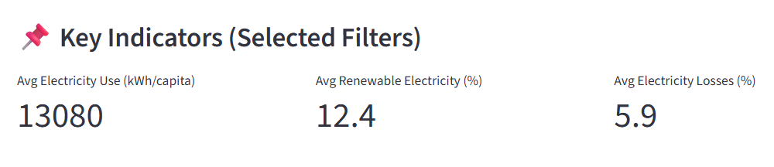
Figure 1Key Indicators of Selected Country

Time-Series Trend Analysis
Electricity Consumption per Capita Over Time
Electricity consumption trends over time were visualised using a line chart. Line charts are well suited for time-series analysis, allowing users to observe growth patterns, stagnation, or fluctuations across years as shown in Figure 2.
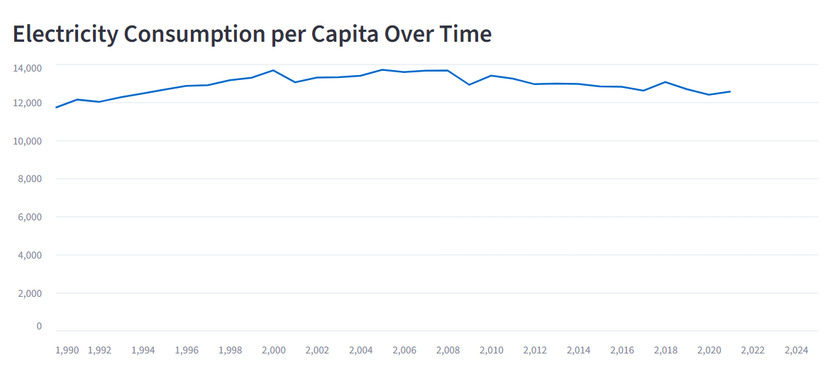
Figure 2 Electricity Consumption per Capita Over Time
Renewable Electricity Share Over Time
A separate line chart presents renewable electricity generation as a percentage of total electricity output. This visualisation highlights energy transition patterns and supports analysis of sustainability trends at the national level as shown in Figure 3.
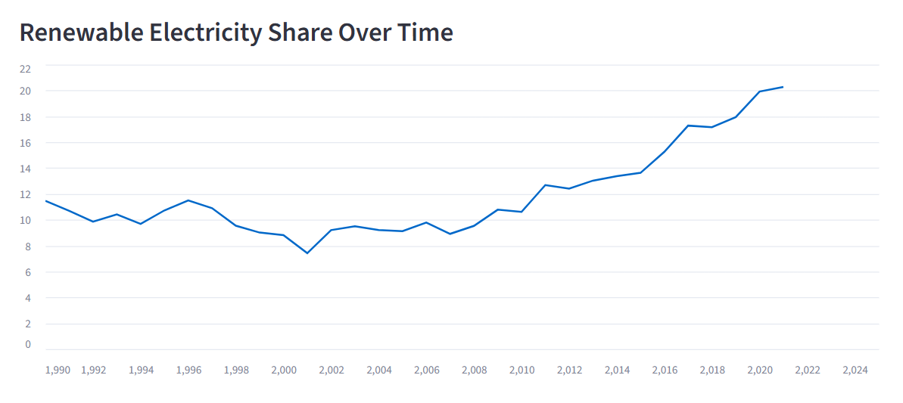
Figure 3 Renewable Electricity Share Over Time
Transmission and Distribution Losses Over Time
Electricity transmission and distribution losses were also visualised using a line chart. This enables identification of improvements or declines in infrastructure efficiency over time.
Using separate charts for each indicator reduces visual clutter and improves interpretability, while consistent colour schemes and axis formatting ensure coherence across visualisations as shown in Figure 4.
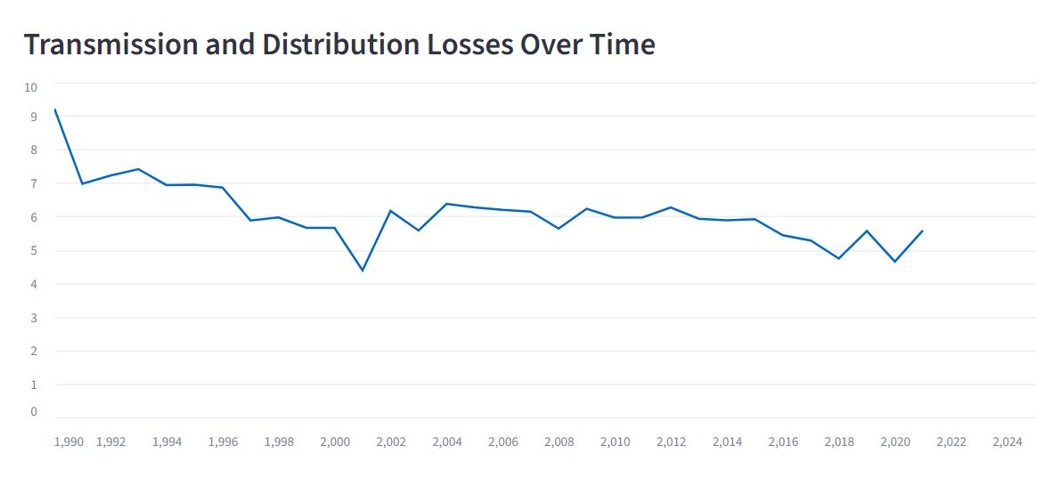
Figure 4 Transmission and Distribution Losses Over Time

Combined and Comparative Visualisations
Dual-Axis Trend Charts
Dual-axis line charts were used to compare electricity consumption with renewable electricity share. Independent y-axes allow indicators with different measurement scales to be analysed simultaneously without distortion as shown in Figure 5.
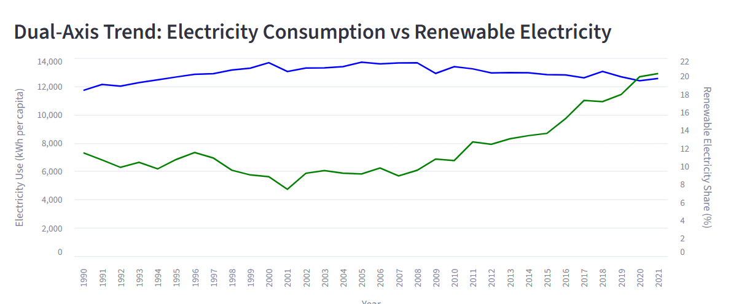
Figure 5 Dual axis chart
Indexed Trend Chart
An indexed line chart (base year = 100) was introduced to compare relative changes across all three indicators. This normalisation enables meaningful comparison between indicators with different units and magnitudes.
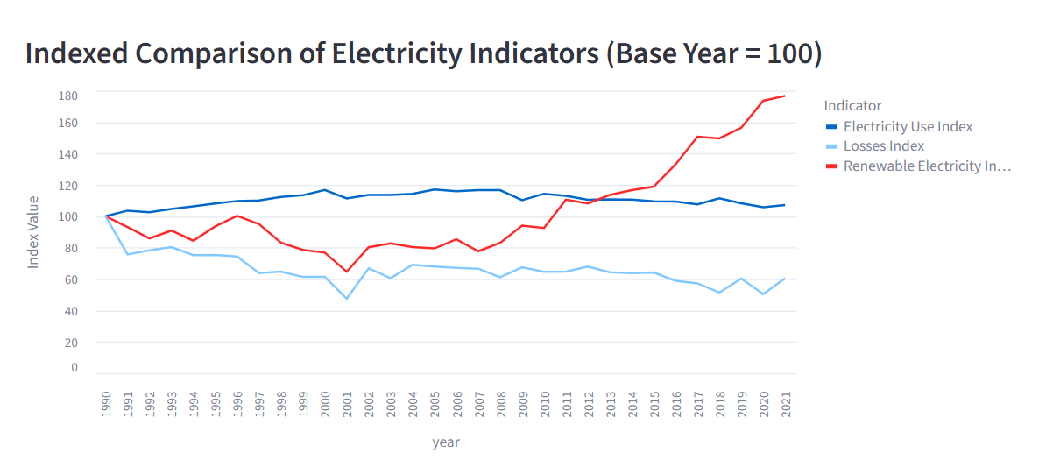
Figure 6 Indexed Trend Chart
Correlation and Relationship Analysis
Ranking and Comparative Analysis
Top-5 Country Rankings
Bar charts were used to display the top countries by electricity consumption for a selected year. Ranking visualisations are effective for comparative and policy-oriented analysis, allowing rapid identification of high-consumption economies.
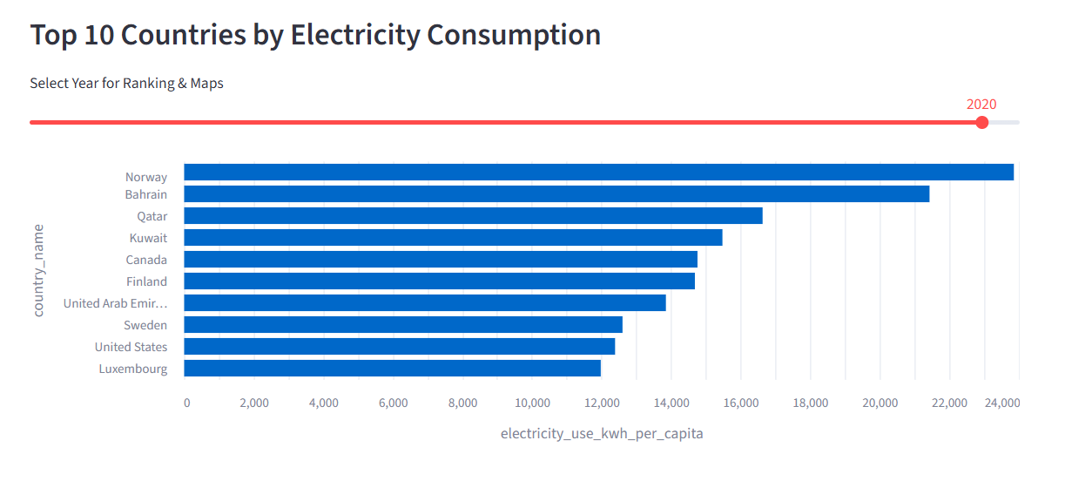
Figure 7 Top-5 Country Rankings
Rank Change (Bump Chart)
Bump charts were used to illustrate changes in country rankings over time. This visualisation highlights shifts in global energy consumption leadership and long-term structural trends.
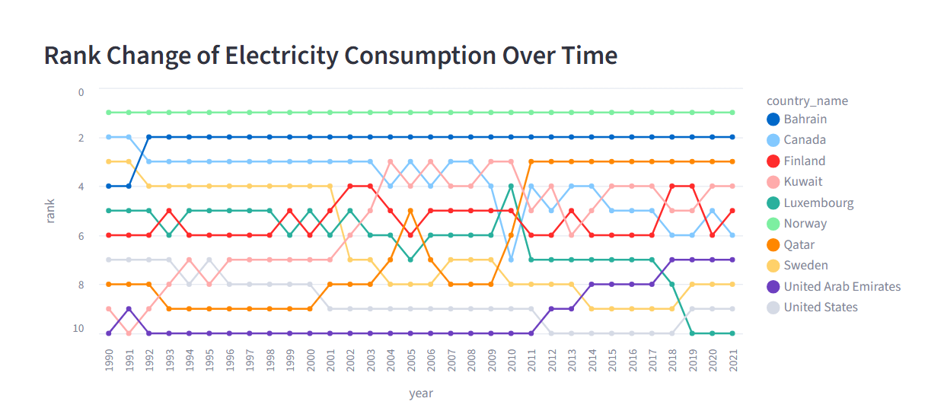
Figure 8 Rank Change of Electricity
Geographic Visualisation
Interactive World Map
An interactive choropleth world map was implemented using Plotly to visualise electricity consumption per capita by country for a selected year. Geographic visualisation enables intuitive spatial comparison and supports identification of regional patterns.
Colour gradients were carefully selected to maintain perceptual clarity and accessibility. Missing values were represented using neutral colours to prevent misinterpretation.
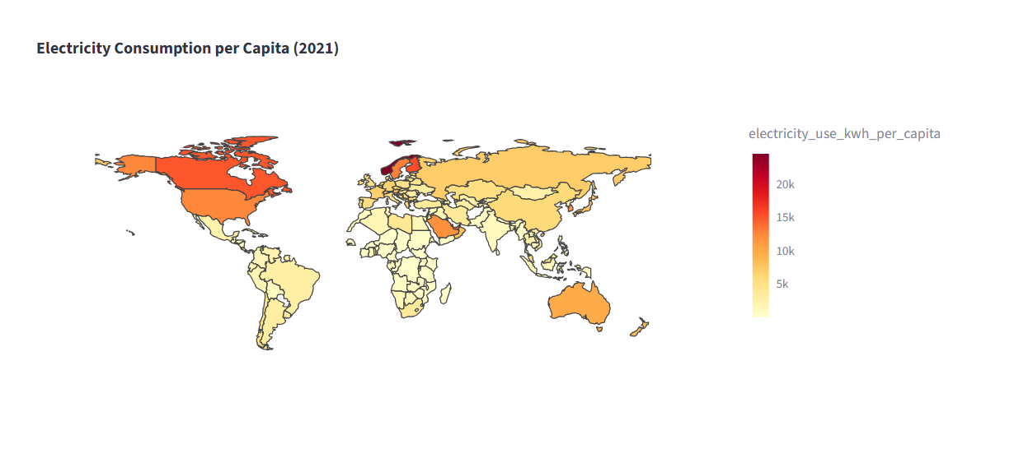
Another interactive choropleth world map was implemented using Plotly to visualise renewable energy percentage by country for a selected year. Geographic visualisation enables intuitive spatial comparison and supports identification of regional patterns.
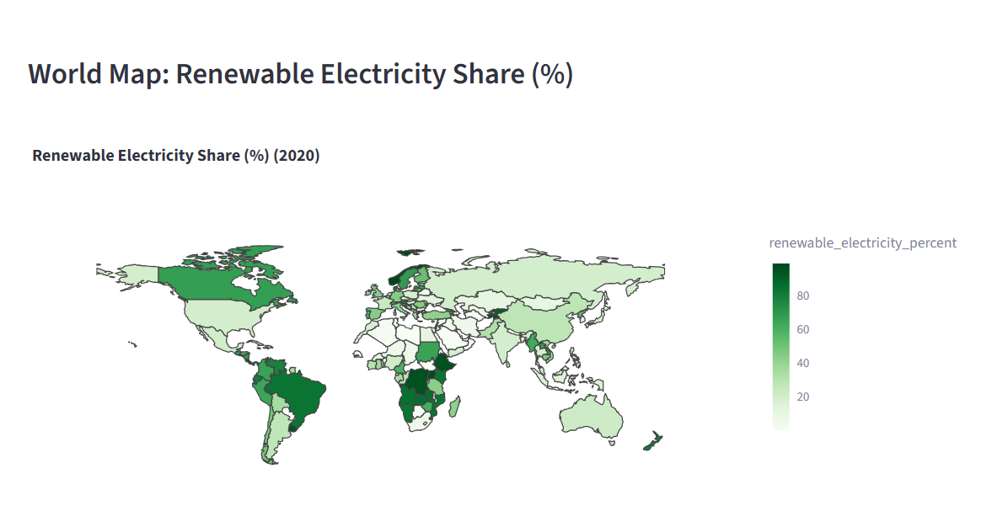

Visualisation Justification Summary
The combination of time-series plots, comparative charts, distribution visualisations, and geographic maps ensures that the dataset is analysed from multiple analytical perspectives. Together, these visualisations support trend analysis, correlation exploration, spatial comparison, and inequality assessment.
By integrating interactivity, consistent design principles, and multiple visual forms, the dashboard effectively translates complex, multi-source electricity data into interpretable and meaningful insights.
Results and Evaluation
This section presents the most significant findings of the combined global electricity dataset and evaluates the effectiveness of achieving the project objectives. The findings rely on exploratory and comparative analysis conducted through interactive visualisations implemented in the Streamlit dashboard.
Summary of Achieved Objectives
The main purpose of the project was to integrate heterogeneous global electricity datasets and investigate trends related to electricity consumption, renewable energy usage, and transmission efficiency. This objective was achieved through the development of an automated data pipeline and a comprehensive visual analytics dashboard.
The dashboard enabled the following:
- Comparison of electricity consumption across different countries and over time
- Analysis of renewable electricity trends and energy transition patterns
- Evaluation of transmission and distribution efficiency
- Investigation of relationships between electricity demand, sustainability, and infrastructure
Trends in Electricity Consumption
Time-series analysis of electricity consumption per capita showed significant variation across countries and time periods. High-income and industrialised countries consistently exhibited higher electricity consumption per capita, which is associated with increased industrialisation and higher living standards. In contrast, lower-income regions demonstrated relatively lower consumption levels.
Several countries showed a gradual increase in electricity consumption over the years, while others experienced stagnation or a gradual decline. These differences reflect variations in economic development pathways and national energy efficiency strategies. Overall, the observed trends validate the use of electricity consumption per capita as an effective indicator of development and electricity demand.
Renewable Electricity Adoption
Analysis of renewable electricity share revealed substantial disparities in national energy policies and generation strategies. Some countries maintained consistently high renewable electricity shares, often due to reliance on hydropower or sustained investment in renewable infrastructure. Other countries demonstrated a steady increase in renewable electricity share over time, indicating ongoing energy transition efforts.
Indexed trend comparison (base year = 100) further showed that in certain regions, renewable electricity adoption increased at a faster rate than overall electricity consumption. This suggests that rising electricity demand does not necessarily correspond to increased fossil fuel dependency and is influenced by policy decisions and infrastructure development.
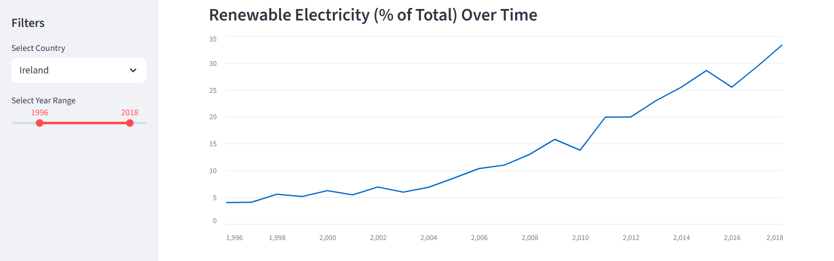
Transmission and Distribution Losses
Transmission and distribution losses varied significantly across countries. Countries with more developed electricity infrastructure generally exhibited lower loss percentages, while higher losses were observed in regions with ageing grids or limited infrastructure investment.
Time-series analysis indicated that losses declined over time in some countries, reflecting infrastructure upgrades and efficiency improvements. However, in other cases, losses remained persistently high, highlighting ongoing structural challenges in electricity delivery systems.

Relationship Between Electricity Consumption and Losses
Scatter plot and bubble chart analysis showed a weak to moderate relationship between electricity consumption per capita and transmission losses. In several cases, higher electricity consumption was associated with lower losses, suggesting that more developed electricity systems tend to operate more efficiently.
However, this relationship was not universal. Some countries exhibited high electricity consumption alongside high transmission losses, indicating inefficiencies despite strong demand. This highlights the importance of analysing infrastructure efficiency independently rather than assuming automatic improvement with increased consumption.
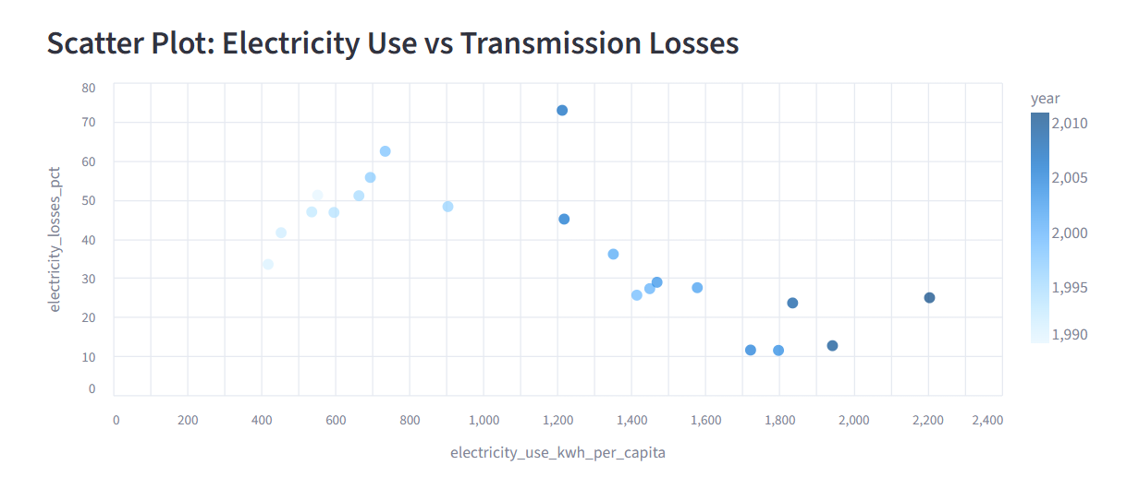
Comparative and Distributional Insights
Ranking and bump chart visualisations illustrated how country positions in electricity consumption rankings changed over time. While some countries maintained relatively stable rankings, others experienced upward or downward shifts, reflecting long-term structural changes in energy demand.
Box plot analysis revealed wide disparities in electricity consumption and transmission losses across countries. The presence of extreme outliers indicates that global electricity systems are highly uneven, with a small number of countries accounting for disproportionately high consumption levels.
Geographic Patterns
Geographic visualisation using a choropleth world map provided an intuitive overview of regional electricity consumption patterns. Higher consumption levels were observed in North America, Europe, and parts of East Asia, while many developing regions showed lower consumption. This spatial perspective reinforces the global inequalities highlighted in the statistical charts.
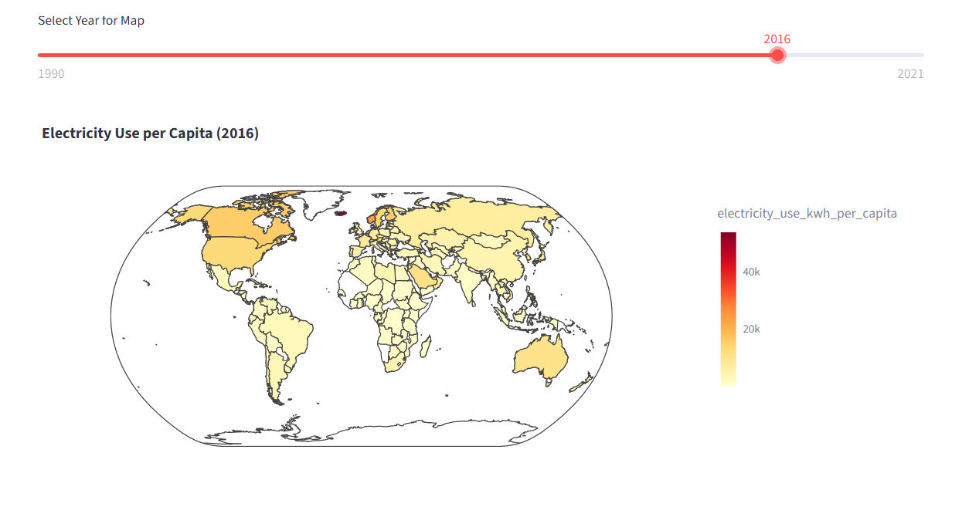
Challenges and Unexpected Patterns
Several challenges were encountered during the analysis. Integrating datasets from different formats required careful standardisation of country identifiers and temporal alignment. In addition, missing values and inconsistent year-to-year reporting limited data availability for certain country–year combinations.
An unexpected pattern observed was that high shares of renewable electricity were not always associated with low transmission losses. In some cases, countries with strong renewable adoption still experienced high losses, indicating that renewable energy generation alone does not guarantee infrastructure efficiency.
Evaluation Summary
Overall, the findings demonstrate that integrating electricity consumption, renewable electricity share, and transmission losses provides a more comprehensive understanding of national electricity systems than analysing any individual indicator in isolation. The project successfully achieved its objectives by combining automated data processing with interactive visual analytics to generate meaningful insights into global electricity trends.
Conclusion and Future Work
The project has shown the integration, processing, and analysis of the heterogeneous worldwide electricity data to produce valuable insights into electricity consumption, renewable energy uptake, and efficiency in the transmission. The project brought together a number of indicators of the World Bank into a single analytical framework, which would not have been achievable by conducting a one-to-one analysis of each indicator.
Its results have indicated that the consumption of electricity per capita is not similar among countries and nations, indicating the differences in economic development, industry, and standards of living. The adoption of renewable electricity had national patterns that were varied with some countries having always high renewable shares and other countries had a gradual change patterns. Transmission and distribution losses also helped to highlight the differences in infrastructure efficiency especially between the developed and developing regions. All these findings respond to the research question of the project, which is to understand the interaction of electricity demand, sustainability, and infrastructure performance in an international level.
One of the critical contributions of the work is that it shows that automated data pipelines, and interactive visual analytics can be used as an aid to exploratory analysis and evidence-based interpretation. A consistent and transparent data processing through the use of a reproducible pipeline and the ability to dynamically explore data trends, relationships, rankings, and geographic patterns using an interactive dashboard were all made possible.
Limitations
In spite of its strengths, this project has got a number of limitations. The first one was that the availability and completeness of the data differed among the countries and years, and this led to the loss of some country-year observations when integrating the data. Second, the study has used only the World Bank indicators and these indicators, despite being good, might not fully reflect all the attributes of a national electricity system e.g. grid stability, energy pricing, or consumption in that particular sector. Third, the analysis was not based on predictive and causal modelling methods but rather on descriptive and exploratory insights.
The other weakness is that the renewable electricity share does not differentiate between various sources of renewable energy, including solar and wind or hydropower which might vary in their implications on sustainability and efficiency of the infrastructure. Also, the transmission losses were considered at a national level which can conceal the regional or sub-national differences.
Future Work
This study has a number of implications on future work. To offer a more holistic view on the energy system, the analysis could be further developed with the help of more indicators, including carbon emissions, electricity prices, or energy access measures. It might also be possible to apply machine learning or statistical models to perform predictive studies of electricity demand or trends in adopting renewable.
The geographic resolution of the data could be further enhanced by providing more data on the sub national scale where possible and separating the various sources of renewable energy. The dashboard would also be more useful in terms of analysis by adding new features like scenario analysis or prediction. Lastly, the pipeline and dashboard deployment on a cloud-computing infrastructure may enhance scalability and be able to support real-time or frequently updated analysis.
Final Reflection
All in all, the given project demonstrates the importance of combining different datasets and implementing visual analytics to more complicated real-life issues. The methodology adopted gives good basis to the future studies and shows how evidence-based strategies can be used to learn about the energy systems in the world and make effective decisions in terms of sustainable energy policy.
References (IEEE Style)
[1] W. Strielkowski, L. Civín, E. Tarkhanova, M. Tvaronavičienė, and Y. Petrenko, “Renewable Energy in the Sustainable Development of Electrical Power Sector: a Review,” Energies, vol. 14, no. 24, p. 8240, 2021, doi: https://doi.org/10.3390/en14248240.
[2] E. Kocak, E. E. Ulug, and B. Oralhan, “The impact of electricity from renewable and non-renewable sources on energy poverty and greenhouse gas emissions (GHGs): Empirical evidence and policy implications,” Energy, p. 127125, Mar. 2023, doi: https://doi.org/10.1016/j.energy.2023.127125.
[3] A. M. Atiku, S. Ismail, F. Roslan, and A. U. Ahmad, “The Effect of Electricity Distribution Loos, Electricity Power Consumption, Electricity Intensity on Energy Consumption in West Africa,” International Journal of Energy Economics and Policy, vol. 12, no. 5, pp. 361–369, Sep. 2022, doi: https://doi.org/10.32479/ijeep.13386.‌
[4] Mustafa NAİMOĞLU, “The effect of energy prices, energy losses, and renewable energy use on CO2 emissions in energy-importing developing economies in the presence of an environmental Kuznets curve,” vol. 30, no. 20, pp. 58755–58772, Mar. 2023, doi: https://doi.org/10.1007/s11356-023-26656-4.
‌[5] J. Grabara, A. Tleppayev, M. Dabylova, L. W. W. Mihardjo, and Z. Dacko-Pikiewicz, “Empirical Research on the Relationship amongst Renewable Energy Consumption, Economic Growth and Foreign Direct Investment in Kazakhstan and Uzbekistan,” Energies, vol. 14, no. 2, p. 332, Jan. 2021, doi: https://doi.org/10.3390/en14020332.
‌[6] Luka Powanga and Paul Adjei Kwakwa, “Determinants of Electricity Transmission and Distribution Losses in South Africa,” Journal of renewable energy, vol. 2023, pp. 1–9, May 2023, doi: https://doi.org/10.1155/2023/2376449.
[7] A. F. Foss, “Power transmission and distribution losses: A model based on empirical data and future trends,” 2019.
[8] F. Durante, A. Gianfreda, F. Ravazzolo, and L. Rossini, “A Multivariate Dependence Analysis for Electricity Prices, Demand and Renewable Energy Sources,” arXiv.org, 2022. https://arxiv.org/abs/2201.01132
[9] Md. S. Alam, F. S. Al-Ismail, A. Salem, and M. A. Abido, “High-Level Penetration of Renewable Energy Sources Into Grid Utility: Challenges and Solutions,” IEEE Access, vol. 8, pp. 190277–190299, 2020, doi: https://doi.org/10.1109/ACCESS.2020.3031481
[10] E. H. Eriksen, L. J. Schwenk-Nebbe, B. Tranberg, T. Brown, and M. Greiner, “Optimal heterogeneity in a simplified highly renewable European electricity system,” Energy, vol. 133, pp. 913–928, Aug. 2017, doi: https://doi.org/10.1016/j.energy.2017.05.170
[11] G. Boyle, Renewable Electricity and the Grid, London, UK: Earthscan, 2007.
[12] World Bank, “World Development Indicators,” The World Bank, 2025. https://databank.worldbank.org/source/world-development-indicators
‌

